**Figure 1**

*Student socioeconomic status*

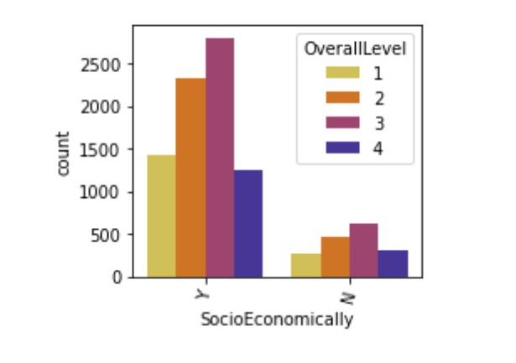

**Figure 2**

*Student housing status*

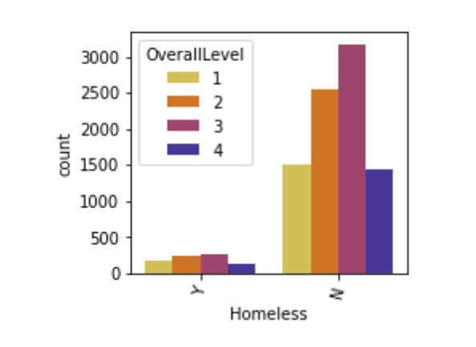

**Figure 3**

*Special Education Status*

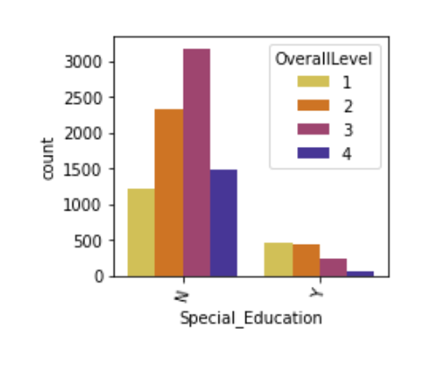

**Figure 4**

*Attendance Distribution*

